The History of Christianity: Timeline and Overview
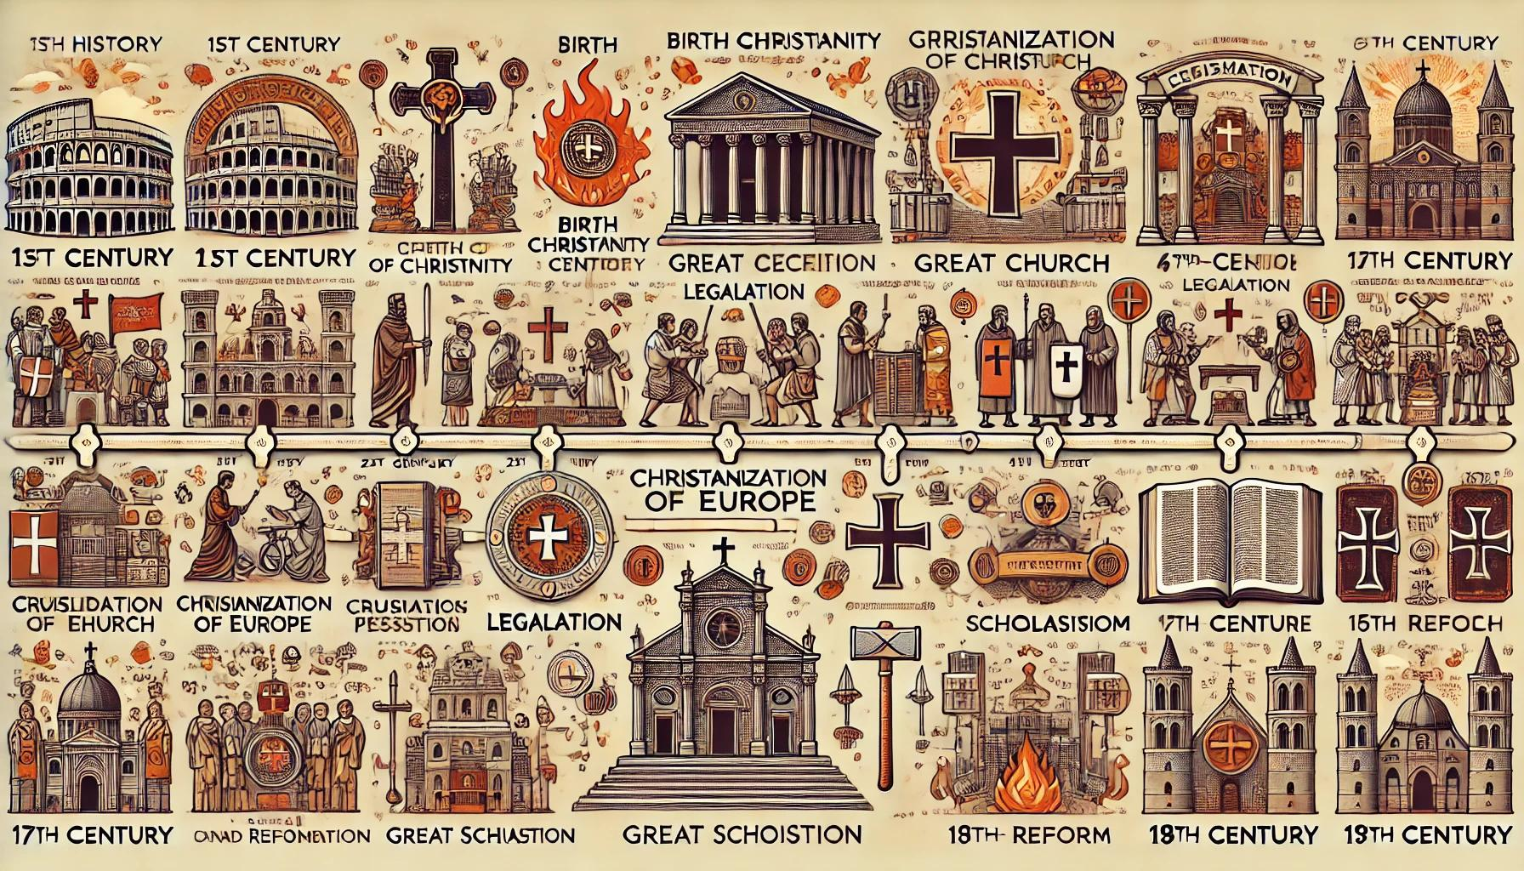
Timeline Infographic: A visual overview of key periods in Christian history.

1st Century (0–100 AD): The Birth of Christianity
- Jesus of Nazareth, born around 4 BC, taught about the Kingdom of God, performed miracles, and claimed to be the Messiah.
- He was crucified around 30–33 AD in Jerusalem under Roman authority. Christians believe He rose from the dead.
- The early Church began in Jerusalem and quickly spread throughout the Roman Empire.
- Pentecost (Acts 2) marked the outpouring of the Holy Spirit and the beginning of the Church's public witness.
- The Apostle Paul played a key role in spreading Christianity beyond Judaism, especially to Gentile populations.
- Key writings of the New Testament were composed during this period, including the Gospels and Paul's epistles.
- Christianity faced sporadic persecution but continued to grow in cities like Antioch, Corinth, Ephesus, and Rome.

2nd–3rd Centuries (100–313 AD): Growth and Persecution
- Christianity expanded through house churches and grassroots evangelism, despite being illegal in the Roman Empire.
- Christians were often persecuted for refusing to worship Roman gods or the emperor.
- Notable martyrs include Ignatius of Antioch, Polycarp, and Perpetua.
- Early Christian theologians (Church Fathers) such as Justin Martyr, Irenaeus, Tertullian, and Origen defended the faith against pagan critics and heresies.
- Key heresies like Gnosticism and Marcionism prompted clarification of core Christian beliefs.
- The formation of the biblical canon began, as churches sought to define authoritative Scripture.
- By the end of the 3rd century, Christianity was a significant minority across the Roman Empire.

4th–5th Centuries (313–500 AD): Legalization and Establishment
- 313 AD: The Edict of Milan, issued by Emperor Constantine, legalized Christianity.
- Constantine favored Christianity, leading to its growth and integration into imperial society.
- 325 AD: The First Council of Nicaea was convened to combat Arianism and produced the Nicene Creed.
- 380 AD: Emperor Theodosius I declared Christianity the official religion of the Roman Empire.
- Monasticism developed as Christians like Anthony the Great retreated into the desert for a life of prayer and simplicity.
- Important theologians included Athanasius, Augustine of Hippo, Jerome, and John Chrysostom.

6th–10th Centuries: Christianization of Europe and East-West Tensions
- After the fall of the Western Roman Empire in 476 AD, the Church preserved learning and order in the West.
- Missionaries like St. Patrick, St. Boniface, and Cyril and Methodius spread Christianity across Europe.
- The rise of the papacy and growing power of bishops shaped medieval society.
- The Eastern and Western Churches began to differ in theology, liturgy, and politics.
- Tensions over papal supremacy and the Filioque clause widened the divide between East and West.

11th Century: The Great Schism (1054 AD)
- The Great Schism formally divided Christianity into Roman Catholic (West) and Eastern Orthodox (East).
- The split was due to theological, political, and cultural differences that had developed over centuries.

12th–13th Centuries: Crusades and Scholasticism
- 1095–1291: The Crusades were military campaigns initiated by the Pope to reclaim the Holy Land.
- The Crusades also had political and economic motivations and led to widespread violence.
- Scholasticism emerged—a theological method using reason to understand faith. Key figures: Anselm, Thomas Aquinas.
- Universities began forming in Europe, often under Church auspices.

14th–15th Centuries: Decline and Calls for Reform
- The Avignon Papacy and Western Schism weakened papal credibility.
- The Black Death killed a large percentage of Europe's population, shaking trust in the Church.
- Reformers like John Wycliffe and Jan Hus criticized Church corruption and promoted access to Scripture.
- 1453: The Fall of Constantinople to the Ottomans ended the Byzantine Empire and weakened Eastern Orthodoxy.

16th Century: The Protestant Reformation
- 1517: Martin Luther nailed his 95 Theses, criticizing the sale of indulgences.
- The Reformation emphasized sola scriptura, sola fide, and sola gratia.
- Other reformers included Calvin, Zwingli, and Knox.
- Protestant denominations emerged: Lutheran, Reformed, Anglican.
- The Catholic Counter-Reformation reaffirmed doctrine and addressed abuses.

17th–18th Centuries: Wars, Denominations, and Revivals
- Thirty Years’ War (1618–1648) ended with religious pluralism in Europe.
- New Protestant groups arose: Baptists, Methodists, Quakers.
- The Enlightenment promoted reason and skepticism of religion.
- The Great Awakenings emphasized personal conversion and evangelism.

19th Century: Missions, Liberalism, and Social Reform
- Missionary movements flourished, spreading Christianity globally.
- The Bible Society movement translated Scripture into many languages.
- Theological liberalism emphasized ethics and reason over supernaturalism.
- The Social Gospel addressed social issues like poverty and inequality.
- Evangelical revivals emphasized conversion and holy living.

20th Century: Global Shift and New Movements
- Christianity's center shifted to the Global South (Africa, Asia, Latin America).
- Pentecostalism spread rapidly, emphasizing spiritual gifts.
- The Ecumenical Movement promoted Christian unity.
- Vatican II reformed the Catholic Church.
- Christianity thrived underground in communist regimes despite persecution.

21st Century: Contemporary Christianity
- Christianity remains the world's largest religion (over 2.4 billion adherents).
- Fast growth in Africa, Asia, and Latin America; decline in secular Western nations.
- Digital evangelism and global prayer networks have emerged.
- Current issues: gender, sexuality, Scripture authority, and persecution.
- Christianity remains diverse and globally influential.

